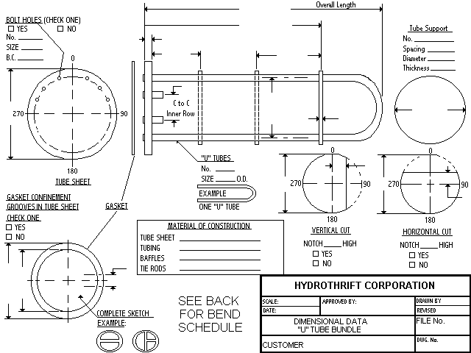
After completed: FAX to (330) 837-0558 or Email to Sales@HydroThrift.com

