
SPECIFICATION DATA - Water Coils Date:________ / Page ____Of____

Name: _____________________________________ Company: ___________________________________________

Address : _______________________________________________________________________________________

City, State, Zip :_________________________________ Tele: ___________________ FAX: ___________________

Job Ref: _________________________________ Coil Model No ____________________________ Qty __________

DIMENSIONAL DATA PERFORMANCE DATA

Fin Height (“FH”) _________ / Finned Length (“FL”) __________ BTU/Hr. _________ Total / ________ Sensible

Rows Deep _______ / Model Type (see table) ______ Airflow ______________ SCFM or Lbs/ Hr

Fins Per Inch ______ / Number of Circuits¹ _________ Face Velocity _________ FPM

Casing Height (“CH”)______ / Casing Length (“CL”) __________ Entering Air Temp. _____ ºF db / _____ ºF wb

Casing Depth (“CD”) ______ / Overall Coil Length (“OL”)_______ Leaving Air Temp. _____ ºF db / _____ ºF wb

Casing Flange Width²: F1_____ F2_____ F3 _____ F4 _____ Air Friction Pressure Drop ______ Inches W.G.

Connection Location³: C1_____ C2 _____ C4 _____ C4 _____ GPM ____ Fluid (if not water & %) _________
Connection Size: __________ Type: □ Sweat □MPT □ FPT Entering Fluid Temperature ______ºF
COIL HAND: (If Horizontal Airflow) □ Right □ Left Leaving Fluid Temperature ______ ºF
(If Vertical Airflow) □ Up □ Down Fluid Pressure Drop __________ Feet of Water
CASING STYLE: □ Encased (shown) □ Non-encased (ends only)

LEFT HAND COIL SHOWN (RIGHT HAND OPPOSITE) Notes: ___________________________
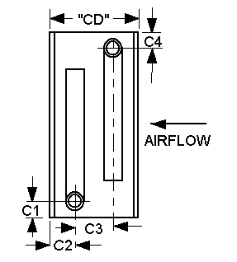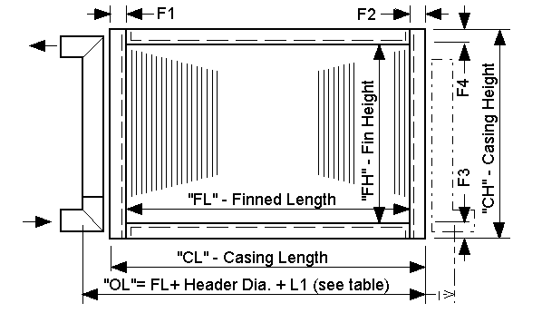___________________________________________________________________________________________________________________________________________________________________________________________________________________________________________________________________________________________________________________________________________________________________________
STANDARD DIMENSIONAL SPECIFICATIONS

MODEL  TYPE | TUBE  O.D. | TUBE CENTERS  FACE X ROW | TUBE  PATTERN | STANDARD FIN HEIGHT INCREMENTS | STANDARD FIN  SPACING MIN - MAX | STANDARD FLANGE WIDTHS  F1, F3, F4, F2 |  | STANDARD  L1 (see 2)
38-1  38-2  38-3  38-4 | 3/8” | 1” x 1”  1” x 1”  1 1/4” x 1”  1” x .866” | Staggered  Inline  Staggered  Staggered | 1”  1”  1 1/4”  1 | 10 - 16  12 only  12 - 16  5 - 18 | 1”  1”  1 1/4”  1” | 1”  1”  1 1/4”  1” | 2 3/8”  2 3/8”  2 7/8”  2 3/8”
12-1  12-2  12-3  12-4 | 1/2” | 1 1/4” x 1”  1 1/2” x 1 1/2”  1 1/2” x 1 1/2”  1 1/2” x 1.299” | Staggered  Staggered  Inline Staggered | 1 1/4”  1 1/2”  1 1/2”  1 1/2” | 8 - 14  10 - 16  10 only  4 - 15 | 1 1/4”  1 1/2”  1 1/2”  1 1/2” | 1 1/4”  1 1/2”  1 1/2”  1 1/2” | 2 7/8”  3 3/8”  3 3/8”  3 3/8”
58-1  58-2  58-3  58-4 | 5/8” | 1 1/2” x 1 1/2”  1 1/2” x 1 1/2”  1 1/2” x 1.299”  1 3/4” x 1.516” | Staggered  Inline  Staggered  Staggered | 1 1/2”  1 1/2”  1 1/2”  1 3/4” | 7 - 10  8 - 10  4 - 15  4 - 15 | 1 1/2”  1 1/2”  1 1/2”  1 1/2” | 1 1/2”  1 1/2”  1 1/2”  1 1/2” | 3 3/8”  3 3/8”  3 3/8”  3 3/8”
88-1  88-2 | 1” | 3” x 2”  3” x 2.598” | Staggered  Staggered | 3”  3” | 4 - 12  4 - 12 | 1 1/2”  1 1/2” | 3”  3” | 6 1/2”  6 1/2”

NOTES: 1. To insure proper replacement coil operation, specify either number of circuits or complete performance data.
2. Note standard flange widths in table. The F2 dimension shown is recommended for tube bend protection on most coils.
3. Indicate direction of inlet and outlet connections if different from above. If multi-section coil, show circuiting and connection details (use separate sheet if necessary). To insure lowest coil cost, specify connection location dimensions only if critical to the installation.

After completed: FAX to (330) 837-0558 or Email to Sales@HydroThrift.com

