SPECIFICATION DATA - Steam Distributing Coils Date:_________Page __ of __

Name: _____________________________________ Company: ___________________________________________

Address : _______________________________________________________________________________________

City, State, Zip :_________________________________ Tele: ___________________ FAX: ___________________

Job Ref: _________________________________ Coil Model No ____________________________ Qty _________

Dimensional Data Performance Data

Fin Height (“FH”)^{A} ________ / Finned Length (“FL”) ________ Heat Load ____________ BTU/Hr.

Rows Deep (1 or 2) _______ / Fins Per Inch^{B} _______ Airflow _______________ SCFM or Lbs/ Hr

Casing Height (“CH”) ______ / Tube Dia. 5/8" or 1" ? _____ Face Velocity _________ FPM

Casing Length (“CL”) _______ / Casing Depth (“CD”) ______ Entering Air Temperature _______ °F

Casing Flange Widths^{C}: F1 _________ F2 __________ Leaving Air Temperature _______ °F

Over Coil Casing and Header Length (“OL”) __________ Saturated Steam Pressure _______ PSIG

Connection Size^{2&3}:Supply _____ MPT / Return _____ MPT Saturated Steam Temp. _________ °F
AIR DIRECTION: □ Horizontal Airflow □ Vertical Airflow Condensate Flow Rate _________ Lbs/Hr.

COIL MOUNTING⁵: □ Horizontal Tubes □ Vertical Tubes Air Friction Pressure Drop ______ Inches W.G.
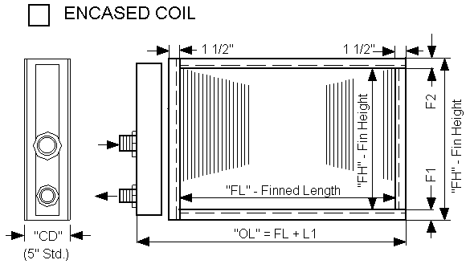
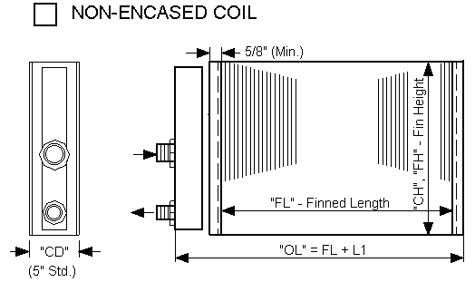

Notes:__________________________________________________________________________________________

_______________________________________________________________________________________________

_______________________________________________________________________________________________

_______________________________________________________________________________________________

_______________________________________________________________________________________________

Standard Dimensional Specifications For 5/8¤ OD and 1¤ OD Tubes

 | A Fin Height | B Fin Spacings | C Flange Widths |  | Connection Size |  | L1
 | Increments | Min - Max | F1 | F2 | Supply | Return | 5/8” O.D. | 1” O.D.
 | 3” (on 1” OD) | 4 -12 | 1 1/2” | 1 1/2” | 1 1/2” | 1” | 6” | -
 | 1 1/2” (on 5/8” | (Other FPI | (1 1/4” |  | 2” | 1 1/2” | 6 1/2” | 10”
 | OD tubes) | Available) | Min.) |  | 3” | 2” | 7” | 10”

Notes:
1. Indicate direction of supply and return connections if different from above (use separate sheet if necessary).
2. Other connection sizes are optionally available. Use “L1” dimensions of next larger supply connection size shown.
3. To insure most economical coil, specify connection location dimensions only if critical to the installation.
4. Unless otherwise specified, standard dimension shown apply to 5/8” OD tube coils only. Consult factory on 1” coils.
5. To insure adequate draining of condensate, coils with horizontal tubes should be installed with a pitch of 1/8” per foot towards return connection. On vertical tube coils, install steam traps on both the supply and return lines.

HydroThrift Corporation Tel: 330-837-5141
P.O.Box 1037 Fax: 330-837-0558
1301 Sanders Ave SW
Massillon, Ohio 44648 USA

After completed: FAX to (330) 837-0558 or Email to Sales@HydroThrift.com

