
SPECIFICATION DATA - Standard Steam Coils Date:_________ Page ________

Name: _____________________________________ Company: ___________________________________________

Address : _______________________________________________________________________________________

City, State, Zip :_________________________________ Tele: ___________________ FAX: ___________________

Job Ref: _________________________________ Coil Model No ____________________________ Qty _________

DIMENSIONAL DATA PERFORMANCE DATA

Fin Height (“FH”)^{A} ________ / Finned Length (“FL”) ________ Heat Load ____________ BTU/Hr.

Rows Deep (1 or 2) _______ / Fins Per Inch^{B} _______ Airflow _______________ SCFM or Lbs/ Hr

Casing Height (“CH”) ______ / Tube Dia. 5/8" or 1" ? _____ Face Velocity _________ FPM

Casing Length (“CL”) _______ / Casing Depth (“CD”) _______ Entering Air Temperature _______ ºF

Casing Flange Widths: F1 _________ F2 __________ Leaving Air Temperature _______ ºF

Over Coil Casing and Header Length (“OL”) __________ Saturated Steam Pressure _______ PSIG

Connection Arrangement² ^{& 3} _______________ Saturated Steam Temp. _________ ºF

Connection Size: Supply _____ MPT / Return _____ MPT Condensate Flow Rate _________ Lbs/Hr.
AIR DIRECTION¹: ◻ Horizontal Airflow ◻Vertical Airflow Air Friction Pressure Drop ______ Inches W.G.
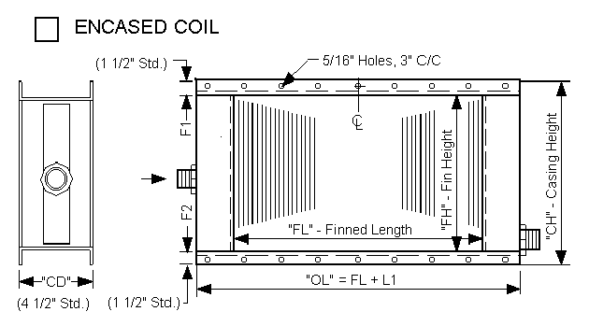COIL MOUNTING:◻ Horizontal Tubes ◻Vertical Tubes
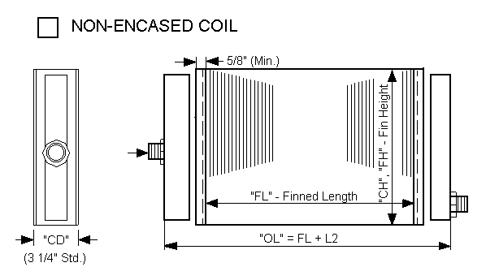

Notes:__________________________________________________________________________________________

_______________________________________________________________________________________________

_______________________________________________________________________________________________

_______________________________________________________________________________________________

_______________________________________________________________________________________________
STANDARD DIMENSIONAL SPECS. STANDARD CONNECTION ARRANGEMENT
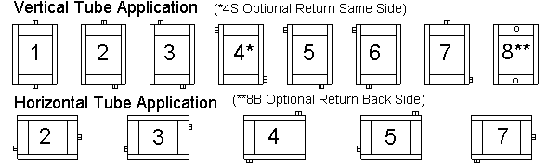
STANDARD CONNECTION SIZES:

Connection Size |  | Encased | Non-Encased
Supply | Return | “L1” | “L2”
1 1/2” | 1” | 9” | 8 1/2”
2” | 1 1/2” | 9” | 8 1/2”
3” | 2” | 9” | 9”

Notes: Notes:
A. Standard fin heights are on; 1.Connection arrangements apply to both encased and non-encased coils.
- 1 1/2" Increments if 5/8" OD tubes Coil hand is universal, permitting airflow in either direction.
- 3" Increments if 1" OD tubes 2.If the required arrangement is not seen above, provide sketch showing details.
B. Standard fin spacings 7 - 12 FPI (contact 3.To insure most economical coil, specify connection location dimensions only factory on other available spacings). if critical to the installation.

After completed: FAX to (330) 837-0558 or Email to Sales@HydroThrift.com

